Finding the range of quadratic functions

Suppose 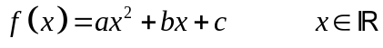

We can work out the turning point 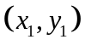 by completing the square or differentiation

If , range will be 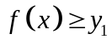

If 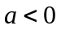, range will be 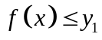

Example

Find the range of 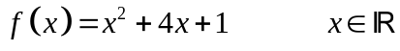

Example

Find the range of 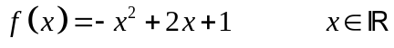
Finding the range of quadratic functions Exercise

Find the range of the following functions for the domain given

- 

 